Hello.We are from Spain

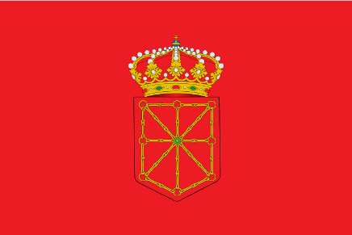

My Autonomus Comunity is called The Comunity of Navarra and it has one province.The capital of Navarra is Pamplona.The municipality where I live is called Pamplona.In my Autonomus Comunity we speak one language

